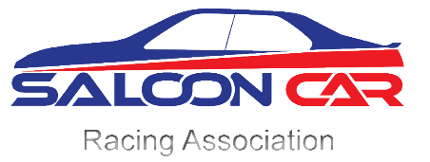
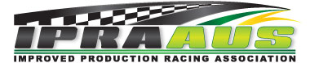

2018 Improved Production Nationals and 2018 Saloon Car Nationals The Bend Motorsport Park November 10-11

Officials Registration

Mr/Mrs/Miss/Dr title Surname surname

First name first name Initial middle initial Date of Birth dob

Address postal address
Primary phone mobile phone | Email email address

Emergency Contact | Phone | Relationship
name | phone | relationship

Preferred Officials Teams e.g. Trackside (1) team 1 (2) team 2

Affiliation/Club club

Officials Licence details - all Officials must hold a current CAMS Officials licence.

Number lic number Expiry date expiry Type type

Recent (last 12 months) experience experience details

I will be available on Saturday ☐ Sunday ☐

I prefer vegetarian meals Yes ☐

Camping Required Yes ☐ No ☐

Please save changes and forward this form to:

jorrocksc@bigpond.com

